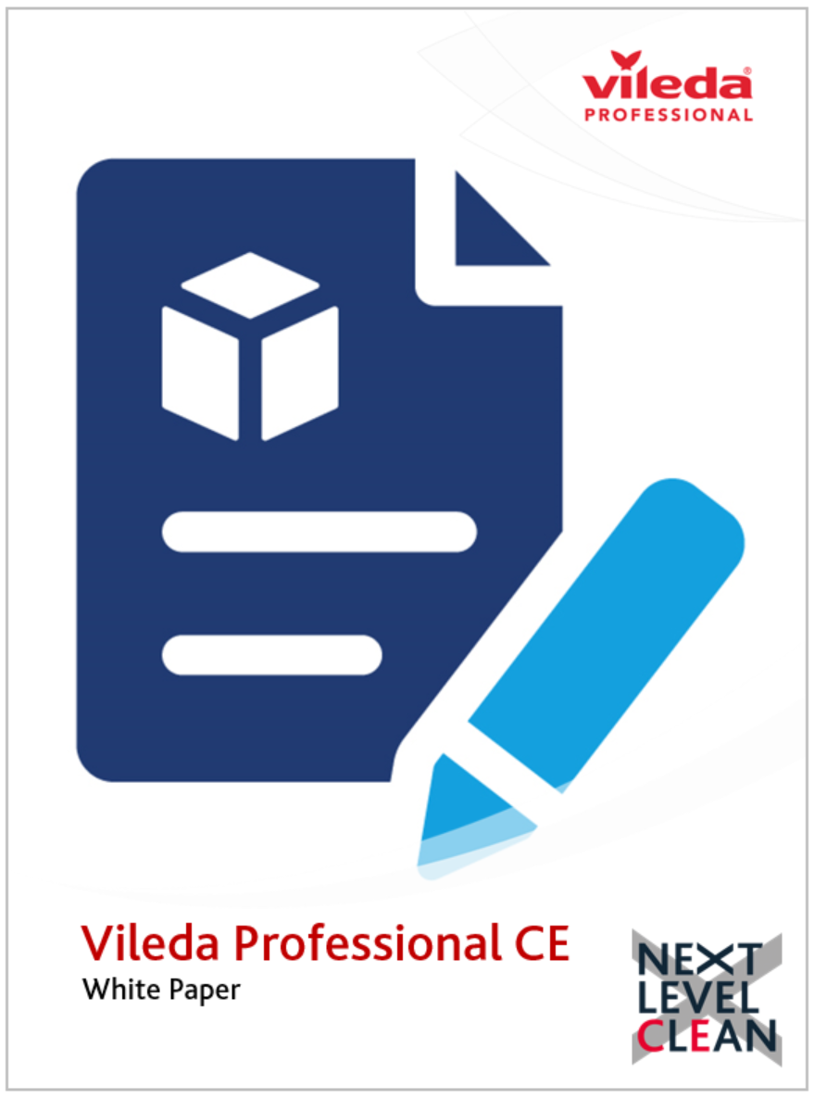
Optimising the Cleaning of Hard-to-Access Equipment in Cleanrooms and Controlled Environments Using Specialist Tools with Microfibre Software Systems.
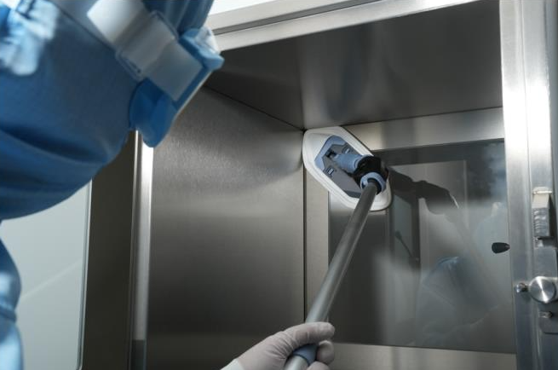
Executive Summary
Cleanrooms and controlled environments are critical in sectors such as pharmaceuticals, biotechnology, medical device manufacturing and cell & gene therapy where contamination control is paramount. Among the key challenges is the effective cleaning of complex, hard-to-access equipment surfaces without compromising contamination control standards. This white paper explores the adoption of specialist cleanroom cleaning tools equipped with microfibre software systems to enhance the efficacy, efficiency and regulatory compliance of cleaning practices in these critical ‘hard to clean’ environments.
1. Introduction
Maintaining ultra-clean environments is crucial to ensure product quality, regulatory compliance, and operational efficiency in cleanrooms. Separative equipment such as Bio-safety cabinets, RABS, isolators, filling lines, laminar flow cabinets, and automated machinery often feature intricate geometries and confined spaces that are notoriously difficult to reach and therefore clean. Traditional cleaning methods may fall short, either leaving behind contaminants or posing risks of damage or cross-contamination risks.
2. Challenges of Cleaning Mini Environment Equipment in Cleanrooms
- Complex Geometry: Equipment often has tight corners, crevices and surfaces with limited accessibility.
- Delicate Surfaces: Sensitive components require non-abrasive cleaning materials.
- Contamination Risks: Ineffective cleaning can introduce microbial or particulate contamination.
- Regulatory Compliance: GMP and ISO 14644 standards necessitate stringent cleaning validation.
3. The Role of Microfibre Software Systems
Microfibre cleaning systems are engineered to remove and retain particles, microbes and residues through a combination of mechanical action and deep fibre network base material. Advanced microfibre materials used in cleanroom applications are laser-cut, pre-laundered and low linting, minimizing the risk of particle shedding.
Key Features:
- High Absorption & Retention: Microfibres capture more contaminants per cleaning pass than std mono-materials.
- Surface Conformity: Material flexibly adapts to uneven or complex surfaces.
- Non-Abrasive: Safe for sensitive equipment surfaces.
- Compatibility: Resistant to commonly used disinfectants and sterilisation processes.
4. Specialist Cleaning Tools for Hard-to-Access Areas
To address accessibility issues, manufacturers have developed tools specifically designed for use in cleanroom environments:
- Flat Mops and Separative Equipment Tools: Slim profiles with flexible necks and articulating heads for cleanroom windows and separative boxes.
- Telescopic Handles: Enable cleaning of high or awkward areas without compromising cleaning technician posture or safety – ergonomic design.
- Sterile-Ready Systems: Gamma-irradiated consumables and tools ensure compliance with aseptic protocols.
5. Integration of Microfibre Systems with Cleaning Protocols Effective integration requires
- Standard Operating Procedures (SOPs): Tailored cleaning protocols detailing the use of specialist tools.
- Validation and Documentation: Demonstration of efficacy and material compatibility.
- Training Programs: Ensuring personnel are proficient in tool use, handling and contamination control SOP’s.
- Tool Management: Procedures for laundering, sterilisation and replacement cycles.
6. Recommendations for a ‘Next Level Clean’
- Conduct an audit of potential hard-to-access, hard-to-clean areas in cleanroom equipment.
- Evaluate and trial specialist cleaning tools and related consumables.
- Develop SOPs integrating these tools into routine cleaning protocols and SOP’s.
- Train staff thoroughly and document all procedures.
- Review and adapt the program regularly based on performance data.
7. Conclusion
Cleaning hard-to-reach, hard-to-access equipment in cleanrooms is a persistent challenge that can be effectively mitigated by leveraging specialist tools equipped with microfibre software systems.
These systems not only improve cleaning efficacy and operational efficiency but also support compliance with stringent cleanroom standards. As regulatory scrutiny intensifies, investing in validated, specialist cleaning tool solutions and systems becomes an operational imperative not a nice to have.
------------------------------------------------------------------------------------------------------------------

About the Author: Vileda Professional CE is a leading manufacturer of mechanical cleaning solutions for cleanroom environments. Our commitment to innovation and compliance drives us to develop systems that meet the rigorous contamination control standards our industry demands.

